
REPUBLIC OF KENYA
MINISTRY OF ENVIRONMENT AND FORESTRY
KENYA METEOROLOGICAL DEPARTMENT

KWALE COUNTY
WEEKLY WEATHER FORECAST

Period of forecast: Tuesday, 21St September, 2021 TO Monday 27Th September, 2021

Date of issue: Monday 20Th September, 2021

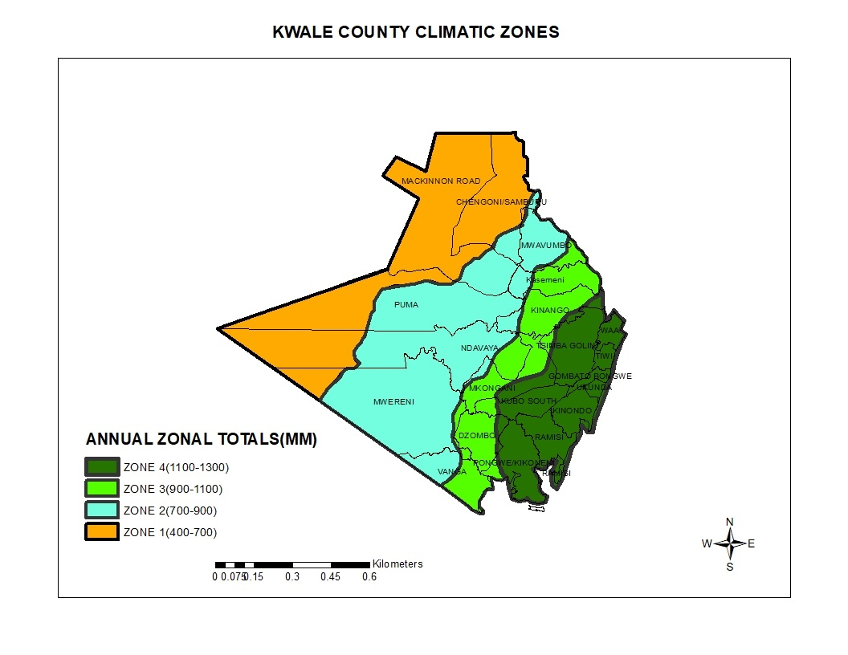

Summary
Light rains in the mornings, afternoon and nights expected in some Wards of Matuga, Msambweni and Lunga Lunga Sub-Counties from Tuesday to Friday this week and Sunday to Monday next week. Few Wards in Kinango Sub-County are likely to receive light rains in the mornings and afternoons on Wednesday, Friday and Sunday. Moderately strong southerly winds of strength 15 – 23 km/h are likely to prevail throughout the forecast period causing small to moderate waves at the Indian ocean.

Matuga, Msambweni and Lunga Lunga Sub-Counties

 | Tuesday | Wednesday | Thursday | Friday | Saturday | Sunday | Monday
Morning |   Light rains(0-2mm) |   Moderate rains(10-15mm) | Moderate rains(0-10mm) | Light rains(0-2mm) |   Sunny Intervals | Light rains(0-2mm) | Light rains(0-2mm)
Afternoon | Sunny Intervals | Light rains(0-5mm) | Sunny Intervals | Sunny Intervals | Sunny Intervals | Sunny Intervals | Sunny Intervals
Night |   Partly Cloudy | Light rains(0-2mm) | Partly Cloudy | Partly Cloudy | Partly Cloudy | Partly Cloudy | Partly Cloudy
Rainfall distribution |  | 
Maximum temperature | 28⁰C | 27⁰C | 28⁰C | 28⁰C | 29⁰C | 28⁰C | 29⁰C
Minimum temperature | 20⁰C | 21⁰C | 20⁰C | 19⁰C | 20⁰C | 20⁰C | 20⁰C
Hazards |   Moderate Waves | Moderate Waves | Moderate Waves | Moderate Waves | Moderate Waves | Moderate Waves | Moderate Waves
Key to rainfall distribution symbols: rain is likely to fall in few places (less than 33%), rain is likely to fall in many places (33-67%),  rain is likely to fall in most places (more than 67%)

Commentary of county weather forecaster:
- Small to moderate waves will prevail in the Indian ocean as moderately strong Southerly winds of 15-23 km/h continues prevailing throughout the forecast period.

Kinango Sub-County

 | Tuesday | Wednesday | Thursday | Friday | Saturday | Sunday | Monday
Morning | Sunny Intervals |   Cloudy | Sunny Intervals | Light rains(0-2mm) | Sunny Intervals | Light rains(0-2mm) | Sunny Intervals
Afternoon | Sunny Intervals | Moderate rains(0-10mm) | Sunny Intervals | Sunny Intervals | Sunny Intervals | Sunny Intervals | Sunny Intervals
Night | Partly Cloudy | Partly Cloudy | Partly Cloudy | Partly Cloudy | Partly Cloudy | Partly Cloudy | Partly Cloudy
Rainfall distribution
Maximum temperature | 29⁰C | 28⁰C | 30⁰C | 30⁰C | 30⁰C | 30⁰C | 31⁰C
Minimum temperature | 22⁰C | 22⁰C | 22⁰C | 21⁰C | 21⁰C | 22⁰C | 21⁰C
Hazards
Key to rainfall distribution symbols: rain is likely to fall in few places (less than 33%), rain is likely to fall in many places (33-67%), rain is likely to fall in most places (more than 67%)

Commentary of county weather forecaster:
No significant weather related impact.

For further information, please contact:

County Director of Meteorology: Dominic M. Mbindyo.
Mobile: 0722581571
Email: cdmkwale@meteo.go.ke

You can find more information about the climate and weather in Kenya on the KMD website http://www.meteo.go.ke/

